Project Planning Phase

Project Planning Report
Project: Script-Controlled ACL – Restrict Record Access Based on Field Value
Date | 1 October 2026
Team ID | SWTID-2026-2527
Project Name | Script-Controlled ACL – Restrict Record Access Based on Field Value
Maximum Marks | 5 Marks

1. Planning approach
This plan converts the Script-Controlled ACL lab into an Agile delivery plan. The work is organized as epics, user stories and three short sprints. Story points use the Fibonacci-style scale referenced by the Phase 4 planning logic: 1, 2, 3 and 5, where larger values represent greater uncertainty or effort.
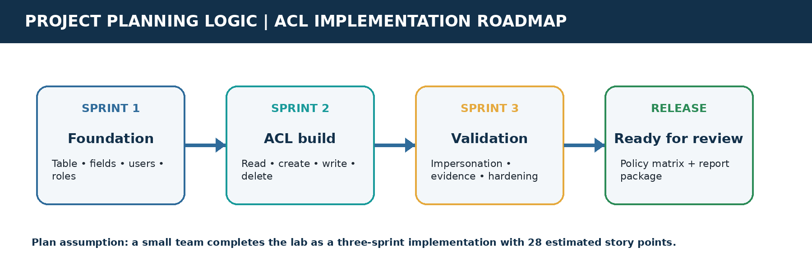
Figure 1. Custom project-specific sprint roadmap; template sample imagery was not reused.

2. Planning terminology applied
Term | Application in this project
Epic | A major capability group: foundation, ACL build, or validation/hardening.
User story | A small, testable implementation task written from the perspective of a user or administrator.
Story point | Relative effort estimate considering configuration, scripting, testing and uncertainty.
Sprint | A fixed five-working-day delivery period with a demonstrable increment.
Velocity | Average story points completed per sprint; used for capacity planning, not as a quality measure.

3. Product backlog
Sprint | Functional Requirement (Epic) | User Story Number | User Story / Task | Story Points | Priority | Team Members
Sprint-1 | Data foundation | USN-1 | As an administrator, I can create `u_institution_details` with the required table settings. | 3 | High | Project team
Sprint-1 | Data foundation | USN-2 | As an administrator, I can add the roll number, references, Branch, contact and Description fields. | 2 | High | Project team
Sprint-1 | Identity and roles | USN-3 | As a security administrator, I can create the EEE test user for controlled verification. | 2 | High | Security admin
Sprint-1 | Identity and roles | USN-4 | As a security administrator, I can create `bb1`–`bb4` and assign the intended role ladder. | 2 | High | Security admin
Sprint-2 | ACL implementation | USN-5 | As a branch user, I can read only EEE records when I have `bb1`; administrators retain full access. | 5 | High | ACL developer
Sprint-2 | ACL implementation | USN-6 | As an authorized user, I can create records when I have `bb2`. | 2 | High | ACL developer
Sprint-2 | ACL implementation | USN-7 | As an authorized user, I can write records when I have `bb3`. | 2 | High | ACL developer
Sprint-2 | ACL implementation | USN-8 | As an authorized user, I can delete records when I have `bb4`. | 2 | Medium | ACL developer
Sprint-3 | Validation and hardening | USN-9 | As a tester, I can impersonate representative users and verify each CRUD outcome. | 3 | High | QA / team
Sprint-3 | Validation and hardening | USN-10 | As a project reviewer, I can inspect evidence screenshots and a completed permission matrix. | 2 | Medium | Documentation
Sprint-3 | Validation and hardening | USN-11 | As a security administrator, I can test negative cases and document production hardening actions. | 3 | High | Security admin

4. Sprint schedule and release plan
Sprint | Total Story Points | Duration | Sprint Start Date | Sprint End Date (Planned) | Story Points Completed (planned) | Sprint Release Date (planned)
Sprint-1 | 9 | 5 working days | 05 Oct 2026 | 09 Oct 2026 | 9 | 09 Oct 2026
Sprint-2 | 11 | 5 working days | 12 Oct 2026 | 16 Oct 2026 | 11 | 16 Oct 2026
Sprint-3 | 8 | 5 working days | 19 Oct 2026 | 23 Oct 2026 | 8 | 23 Oct 2026

Release plan: each sprint produces a usable increment in the same ServiceNow development instance. Sprint 1 establishes the data and identity foundation; Sprint 2 adds the ACL policy layer; Sprint 3 verifies behavior, captures evidence and prepares the project for review.

5. Project tracker and definition of done
Workstream | Tracker checkpoints | Definition of done
Foundation | Table exists; fields match the data model; sample ECE/EEE/CSE records exist. | Configuration saved, records load correctly, and evidence is captured.
ACL implementation | Each operation has an active ACL, correct role and documented behavior. | READ/CREATE/WRITE/DELETE outcomes are reproducible through impersonation.
Validation | Positive and negative cases executed; admin bypass verified. | Test results and screenshots are mapped to acceptance criteria.
Documentation | Permission matrix, limitations and hardening actions recorded. | Reviewer can understand how access is granted or denied without opening the instance.

6. Velocity calculation
Sprint | Planned completed points | Capacity interpretation
Sprint-1 | 9 | Foundation and role setup
Sprint-2 | 11 | Highest-complexity ACL scripting and configuration
Sprint-3 | 8 | Verification, evidence and hardening
Total | 28 | Total estimated scope

Average planned velocity = total planned story points ÷ number of sprints = 28 ÷ 3 = 9.33 story points per sprint. Because this is an initial plan with no historical team data, 9.33 is a planning baseline rather than a measured team velocity. After Sprint 1, the remaining sprint capacity should be recalibrated using completed work and any discovered ACL complexity.

7. Planned burndown chart
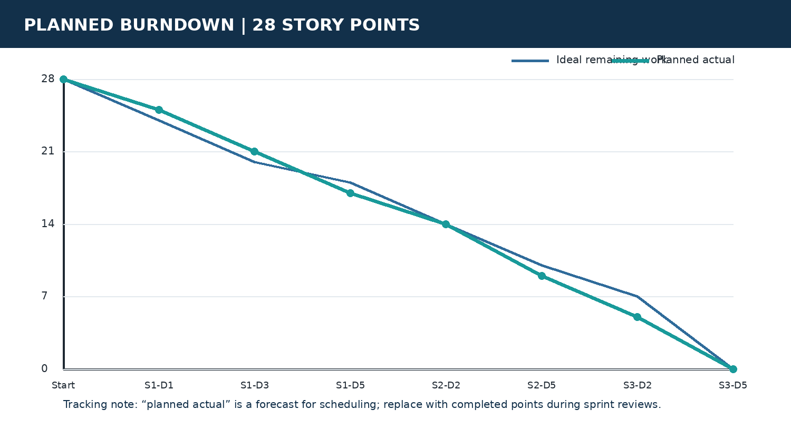
Figure 2. Planned burndown for the 28-point backlog; the forecast should be replaced with actual sprint-review data.

8. Project evidence and planning traceability
The plan is grounded in the existing project implementation rather than a generic software example. The following evidence links backlog items to the work described in the source project document.

USN-2: field configuration evidence
The source project shows the table-column configuration for the institution details table, supporting the data-foundation stories.
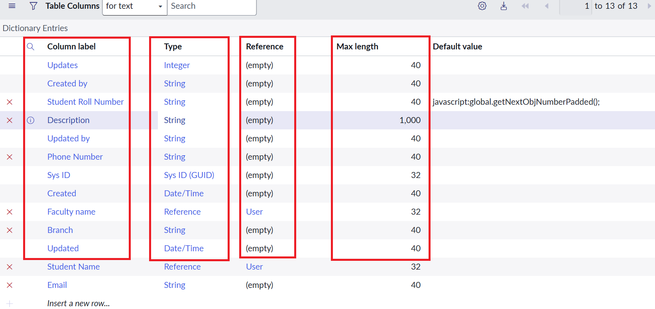
Project evidence screenshot: USN-2: field configuration evidence

USN-5: READ ACL scripting evidence
The source project shows the branch data condition and advanced script used to evaluate the READ policy.

Project evidence screenshot: USN-5: READ ACL scripting evidence

USN-5 to USN-8: ACL operation evidence
The source project shows an operation-specific ACL form with role and table configuration, supporting the CRUD implementation stories.

Project evidence screenshot: USN-5 to USN-8: ACL operation evidence

USN-9: verification data context
The source project shows the institution records list with branch values used to verify access outcomes.

Project evidence screenshot: USN-9: verification data context

9. Risks, assumptions and planning controls
- Assumption: the project team has access to a ServiceNow instance with permission to elevate `security_admin` when creating ACLs.
- Risk: create/write/delete may require branch-specific conditions in a production policy even though the lab design explicitly applies the Branch condition to READ; resolve this in Sprint 3 hardening.
- Risk: role inheritance or pre-existing ACLs may change observed results; test in a clean or documented instance and record baseline configuration.
- Control: use impersonation-based acceptance tests for no-role, bb1, bb1+bb2, bb1+bb2+bb3, bb1+bb2+bb3+bb4 and admin states.
- Control: treat the velocity as a forecast until actual completed points are available; do not add scope without re-estimating the burndown.

10. Conclusion
The Phase 4 plan delivers the ACL project in three manageable increments with a 28-point backlog, explicit ownership, planned release dates, a measurable velocity baseline and a burndown forecast. It preserves the project’s security objective while adding the planning artifacts needed to execute, review and improve the implementation.

References
Primary source: project document “Script-Controlled ACL – Restrict Record Access Based on Field Value,” supplied by the project owner. Planning structure adapted from the supplied Phase 4 Project Planning Template and Planning logic document. Template references include Atlassian Agile/Scrum guidance and Visual Paradigm burndown-chart guidance.

